Unit Test

The unit test of the AdhocTicketDAO, AdhocticketFactory, AdhocTicket, and ExitController was done using JUnit to comprehensively test them and some appropriate objects to isolate the class under test.

# AdhocTicketDAO

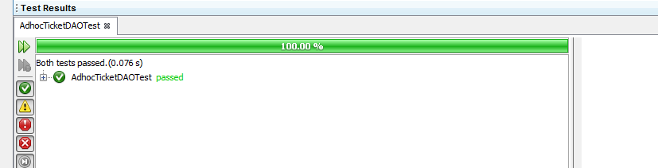

JUnit test report

## AdhocTicketDAOTest.java code

import bcccp.tickets.adhoc.AdhocTicket;

import bcccp.tickets.adhoc.AdhocTicketDAO;

import bcccp.tickets.adhoc.AdhocTicketFactory;

import bcccp.tickets.adhoc.IAdhocTicket;

import bcccp.tickets.adhoc.IAdhocTicketFactory;

import java.util.List;

import org.junit.After;

import org.junit.AfterClass;

import org.junit.Before;

import org.junit.BeforeClass;

import org.junit.Test;

import static org.junit.Assert.*;

public class AdhocTicketDAOTest {

AdhocTicket aht;

AdhocTicketDAO adtd;

@Before

public void setUp() {

aht = new AdhocTicket("C112", 1, "RF34112");

adtd = new AdhocTicketDAO(new AdhocTicketFactory());

}

@After

public void tearDown() {

aht = null;

adtd = null;

}

@Test

public void createticket() {

int expected=1;

IAdhocTicket iatc= adtd.createTicket(aht.getCarparkId());

int actual = iatc.getTicketNo();

assertEquals(expected, actual);

}

@Test

public void findticket_ByBarcode() {

String expected="A1";

IAdhocTicket iatb= adtd.createTicket(aht.getCarparkId());

String actual = iatb.getBarcode();

assertEquals(expected, actual);

}

}

# AdhocticketFactory

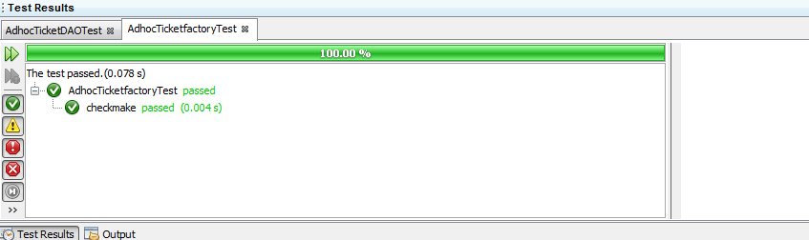

## AdhocTicketFactoryTest.java Code

import bcccp.tickets.adhoc.AdhocTicketFactory;

import bcccp.tickets.adhoc.IAdhocTicket;

import org.junit.After;

import org.junit.AfterClass;

import org.junit.Before;

import org.junit.BeforeClass;

import org.junit.Test;

import static org.junit.Assert.*;

public class AdhocTicketfactoryTest {

AdhocTicketFactory att;

@Before

public void setUp() {

att = new AdhocTicketFactory();

}

@After

public void tearDown() {

att = null;

}

@Test

public void checkmake() {

String expectedcarparkid="C112";

int expectedtkt=1;

IAdhocTicket ahtt=att.make(expectedcarparkid,expectedtkt);

String actualcarparkid=ahtt.getCarparkId();

int actualticketno=ahtt.getTicketNo();

//check carparkid

assertEquals(expectedcarparkid, actualcarparkid);

//check ticket

assertEquals(expectedtkt, actualticketno);

//check barcode

assertEquals("A"+expectedtkt,ahtt.getBarcode());

}

}

# AdhocTicket

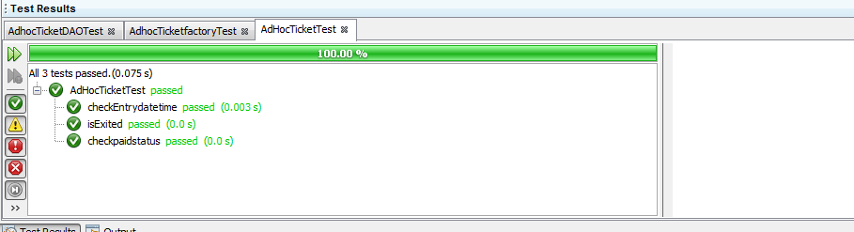

## AdhocTicketTest.java Code

import bcccp.tickets.adhoc.AdhocTicket;

import org.junit.After;

import org.junit.AfterClass;

import org.junit.Before;

import org.junit.BeforeClass;

import org.junit.Test;

import static org.junit.Assert.*;

public class AdHocTicketTest {

private AdhocTicket adt;

@Before

public void setUp() {

adt = new AdhocTicket("C112", 1, "RF34112");

}

@After

public void tearDown() {

adt = null;

}

@Test

public void checkEntrydatetime() {

long actual = 0402120620;

adt.enter(actual);

long expected = adt.getEntryDateTime();

assertEquals(expected, actual);

}

@Test

public void checkpaidstatus() {

adt.pay(1204140630, 40);

assertFalse(adt.isCurrent());

assertTrue(adt.isPaid());

}

@Test

public void isExited()

{

long expected=1204140630;

adt.exit(1204140630);

assertEquals(expected, adt.getExitDateTime());

assertTrue(adt.hasExited());

}

}

# ExitController

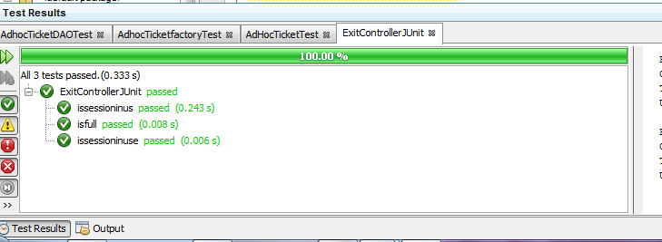

## ExitControllerTest.java Code

import bcccp.carpark.CarSensor;

import bcccp.carpark.Carpark;

import bcccp.carpark.Gate;

import bcccp.carpark.ICarSensor;

import bcccp.carpark.IGate;

import bcccp.carpark.exit.ExitController;

import bcccp.carpark.exit.ExitUI;

import bcccp.carpark.exit.IExitUI;

import bcccp.tickets.adhoc.AdhocTicketDAO;

import bcccp.tickets.adhoc.AdhocTicketFactory;

import bcccp.tickets.adhoc.IAdhocTicketDAO;

import bcccp.tickets.season.ISeasonTicket;

import bcccp.tickets.season.ISeasonTicketDAO;

import bcccp.tickets.season.SeasonTicket;

import bcccp.tickets.season.SeasonTicketDAO;

import bcccp.tickets.season.UsageRecordFactory;

import org.junit.After;

import org.junit.AfterClass;

import org.junit.Before;

import org.junit.BeforeClass;

import org.junit.Test;

import static org.junit.Assert.*;

public class ExitControllerJUnit {

private IAdhocTicketDAO adhocTicketDAO;

private ISeasonTicketDAO seasonTicketDAO;

private ExitController ec;

private IGate ig;

private ICarSensor incs;

private ICarSensor oucs;

private IExitUI ieu;

private Carpark cp;

private ISeasonTicket t1;

@Before

public void setUp() {

adhocTicketDAO = new AdhocTicketDAO(new AdhocTicketFactory());

seasonTicketDAO = new SeasonTicketDAO(new UsageRecordFactory());

ig = new Gate(1330, 320);

incs = new CarSensor("Entry Inside Sensor", 20, 440);

oucs = new CarSensor("Entry Outside Sensor", 20, 100);

ieu = new ExitUI(1000, 100);

cp = new Carpark("BMW", 2, adhocTicketDAO, seasonTicketDAO);

ec = new ExitController(cp, ig, incs, oucs, ieu);

t1 = new SeasonTicket("S1111", "Bathurst Chase", 0L, 0L);

cp.registerSeasonTicket(t1);

cp.issueAdhocTicket();

cp.recordAdhocTicketEntry();

cp.recordSeasonTicketEntry(t1.getId());

}

@After

public void tearDown() {

adhocTicketDAO = null;

seasonTicketDAO = null;

ig = null;

incs = null;

oucs = null;

ieu = null;

cp = null;

ec = null;

}

@Test

public void issessioninus() {

assertTrue(cp.isSeasonTicketValid("S1111"));

assertFalse(cp.isSeasonTicketValid("S1211"));

}

@Test

public void issessioninuse() {

assertTrue(cp.isSeasonTicketInUse("S1111"));

}

@Test

public void isfull() {

assertTrue(cp.isFull());

}

}

# Bibliography

*JUnit test* Available at: <https://www.tutorialspoint.com/junit/junit_test_framework.htm>

vogell(2012) *JUnit Tutorial*. Available at: <http://www.vogella.com/tutorials/JUnit/>